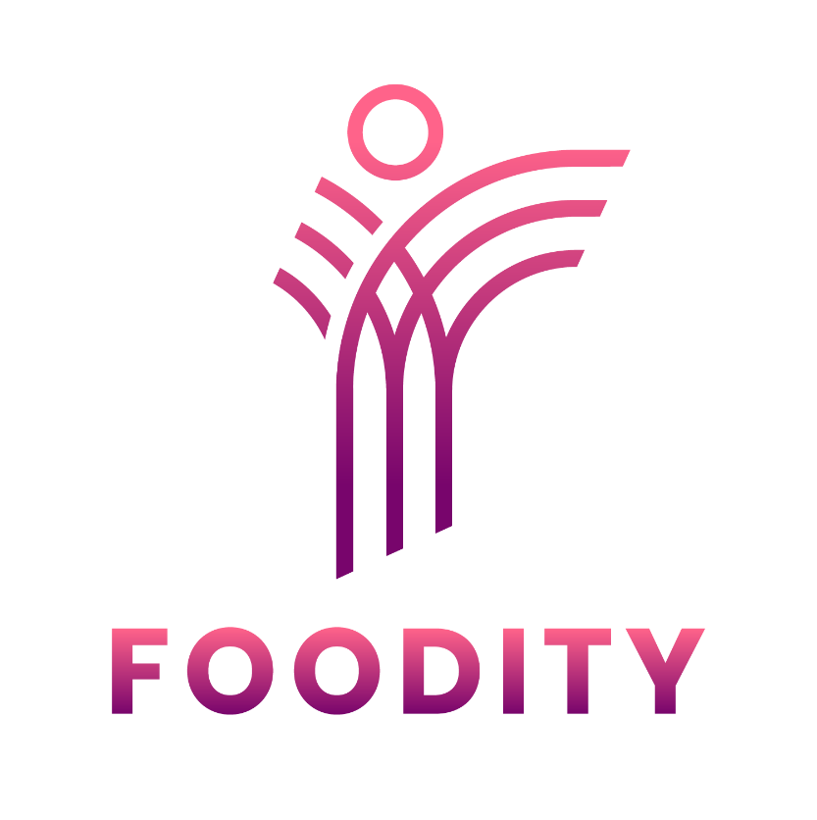

Frequently Asked Questions

FOODITY – Open Call #1

FREQUENTLY ASKED QUESTIONS

- Do partners have to be from the same country?
No, partners can be from different countries. Partners can also be from the same country, however, at least one entity must be from within Europe.
- Can a corporation form part of a consortium?
No, corporates are not eligible for this call. Only SMEs are qualified, both in terms of technical partners and social innovation actors. FOODITY applies the European Commission definition of SMEs, which can be found here.
- Are universities eligible?
Yes, universities fall under the category of “research and training institutions”.
- Are there expectations regarding budget allocation per partner within a consortium?
No, there are no requirements on budget allocation within a given consortium. It must be decided internally on an appropriate budget per partner while keeping in mind that costs must be logical and justified.
- Is Hungary eligible?
Applicants from Hungary will be evaluated on a case-by-case basis. It is advised that if you are an entity registered in Hungary, to speak with your National Contact Point before applying.
- Are there exceptions to the TRL minimum and maximum?
No, the minimum TRL is 4 and any proposals that fall under this minimum will be automatically deemed ineligible. Any applications in which the TRL is above 6 will also be automatically deemed ineligible.
- Are the components provided by the FOODITY consortium open access?
The components differ in their accessibility. It is advised to read carefully through Technical Annex 1.1 for more information about the licensing.
- Can my company’s own data platform be connected with FOODITY’s datalake?
An API can be used to connect your data platform with FOODITY’s datalake. Please contact us at opencalls@foodity.eu for more details.
- Does FOODITY expect pilots to have a market-ready product by the end of the programme?
Although the goal of the pilot programme is for participating consortia to scale their solutions to TRL 7 and become market-ready, this is not an expectation. It is understood that consortia entering the programme at TRL 4, for example, may only manage to advance to TRL 6 over the course of one year.

- Who are the mentors going to be?
The mentors have not yet been onboarded and will be selected by a public Expression of Interest (EoI). It is advised to read through the project’s Open Call Guidelines to understand how the mentoring will work.
- How long does it take to submit an application?
There is no standard amount of time a given application takes to complete. It depends on how far developed your proposed solution is, how well the Guidelines have been understood, as well as the evaluation criteria, and your experience with EU funds. It is advised to start as soon as possible to avoid rushing through the proposal.

